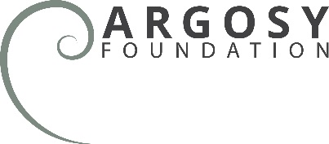

PROGRESS REPORT 2016
Date Completed:
ORGANIZATION INFORMATION

Name of Organization:
Contact Name and E-mail:
REQUEST INFORMATION

Grant Amount:
Grant Period (start date and end date):
Project Title:

NARRATIVE

Please answer the following questions and submit this form as an email attachment to the program officer you are working with at the Argosy Foundation. If this is a final report, please only include information that is new since your last progress report.
- What were your significant accomplishments during this period? (Compare to outcomes and benchmarks described in your proposal to the Argosy Foundation.)

- What challenges/barriers to success did you encounter? How did you respond to these challenges?

- Have there been any significant organizational or staffing changes? (Please compare to information about staff involved as included in your proposal to the Argosy Foundation.)

- What are your goals for the next phase of work?
- What have you learned in the process of doing this project that will:
- influence future efforts of your program/organization;
- be useful/valuable to other organizations and funders?

6. If applicable, what are your plans for disseminating program outcomes or lessons learned?
- Account for project expenses incurred to date, comparing these expenses to the original project budget.

8. What has this grant enabled you to accomplish that you might not have been able to otherwise?
- Have you received other funding for this initiative? Please list the sources and amounts.

10. What press or other coverage has the organization received or drafted about the program supported? If any, please include an electronic copy (web link or email attachment).
- Is there anything else you’d like to share with the foundation?

